Connie Chau

05-430 PUI

Section A: Kristin Williams

2 December 2018 (extension)

Homework 8 Write-up

Link: <https://cwchau.github.io/PUI-Final-Project/>

Part 1)

i. My website is a portfolio of the handful of projects that I currently have.

ii. The information I wanted to convey with my website were the projects that I have worked on in the past. Because I do not have very many design-focused or structured projects, there is currently not a lot of text looking into my design process. I’m still new to HCI but my hope was to show the glimpses of understanding certain concepts such as user testing in the projects that I have already done. It is for this reason that the first thing anyone sees for each project page is the “Context”, “Key Skills”, and “Tools Used”. In addition to being useful advice I received at a portfolio review, it is very helpful to put that first impression of the things that I am at least *learning* and have used in some context.

iii. My website is interesting and engaging through colors and small interactions. A main feature that I implemented was a little animation and mouse interaction with the header. However, I opted to show more restraint because having asked others about portfolios online and researched some on my own, I found that too many visually-stimulating elements distract from the main purpose of a web portfolio which is to relay information about you and your projects. Instead, I chose to do more subtle things like fading page animations, hover changes, embedded videos, a scroll to top feature, and a project selector menu on the homepage. There are enough interactions for users to feel they have control over their experience on my site but enough restraint so they aren’t tempted to go elsewhere.

iv. The target audience would be employers or my peers—anyone who is interested in what I have done.

Part 2) These steps can be done in order.

* i. Header mouse interaction (for fun)

ii. On any page, move your mouse (left and right) to see the moon move and wax/wane

* i. Hover over project boxes (to know what project is being ‘selected’)

ii. On the homepage, each project item will darken when you hover over it

* i. Project Selection to help narrow down options (or just to see how they’re categorized)

ii. On the homepage, there are four buttons (All, Internship, Coursework, Personal). Select the “Internship” button and the item (MTG UX Internship) will be the only one to appear. Select “All” to view all the items again.

* i. Pictures in automatic carousel

ii. Select the “MTG UX Internship” item. It will take you to that project’s page. Scroll down and in the middle, there will be a carousel. Click on the red squares to toggle to the previous or next picture. It will also automatically go through the images.

* i. Scroll to top while you’re reading a longer project page

ii. While you were scrolling, there appeared an arrow pointing upward icon on the right of the screen. Click on it to bring you back up to the top of the page.

* i. Learn more about me and gain access to external profiles

ii. Select ‘about’ in the navigation bar. It will bring you to my about page from where you can read a little bit about me and links to my Github and LinkedIn (which open up in new tabs).

* i. External links that will open a new tab so you aren’t detracted completely from the portfolio website

ii. Select ‘home’ in the navigation bar again. Select ‘Twitter Chatbot’. If you scroll a little down, you will see a green text hyperlink. Select it and it will open up the ‘Kaggle Dataset’ in a new tab. Exit out of tab and return to the portfolio website.

* i. Embedded video from the project

ii. Select the word “home” in the navigation bar, select “Body Music Generator”. Scroll down a little and there will be a Youtube video embedded in the page. Click on the video to play and pause when you want to.

\*\* Note: The search bar is not functional but may be used in later iterations.

Part 3)

* i. p5.js

ii. I wanted to create some self-generated visuals and animations.

iii. The header is both animated and interactive and was coded using p5.js.

iv. It adds a general “theme” and some visually-stimulating elements to capture a user’s attention. My name is also nearby and people can more likely remember what they do versus what they read (making the site memorable).

* i. Animate.css

ii. I chose it because it was intuitive to use and provided a variety of nice, not-too-obtrusive animations.

iii. I used it to fade in content so it would look a little less jumpy. The header where my name resides is also subtly animated to move and become larger then smaller.

iv. I think it makes the flow of the experience better and less disjointed. While the page is loading, they will be temporarily distracted by the animation itself. I also used it for the ‘Baguette’ page to illustrate that it needed more documentation-type materials.

* i. Bootstrap

ii. It is a common library for website-building and comes with many built-in features.

iii. I used it for responsiveness, embedded video links, carousels, navigation bar, and footer.

iv. It adds responsiveness to my website but also better structure in terms of layout. The built-in classes that Bootstrap 4 offers was very nice especially those with responsive embedded videos, carousels, and the cards.

Additional code references (also commented in code):

Scroll to Top: <https://codepen.io/karencho/pen/KIgur>

Image Selector: <https://mdbootstrap.com/plugins/jquery/gallery/>

Part 4)

I made a lot of changes from my original website because I conducted a series of user tests to both improve my design and practice my prototyping and critique skills. In terms of visual layout, the biggest thing that changed was the homepage and how to display all my projects. Here are some of the later ideas I played around with to reach the final iteration:

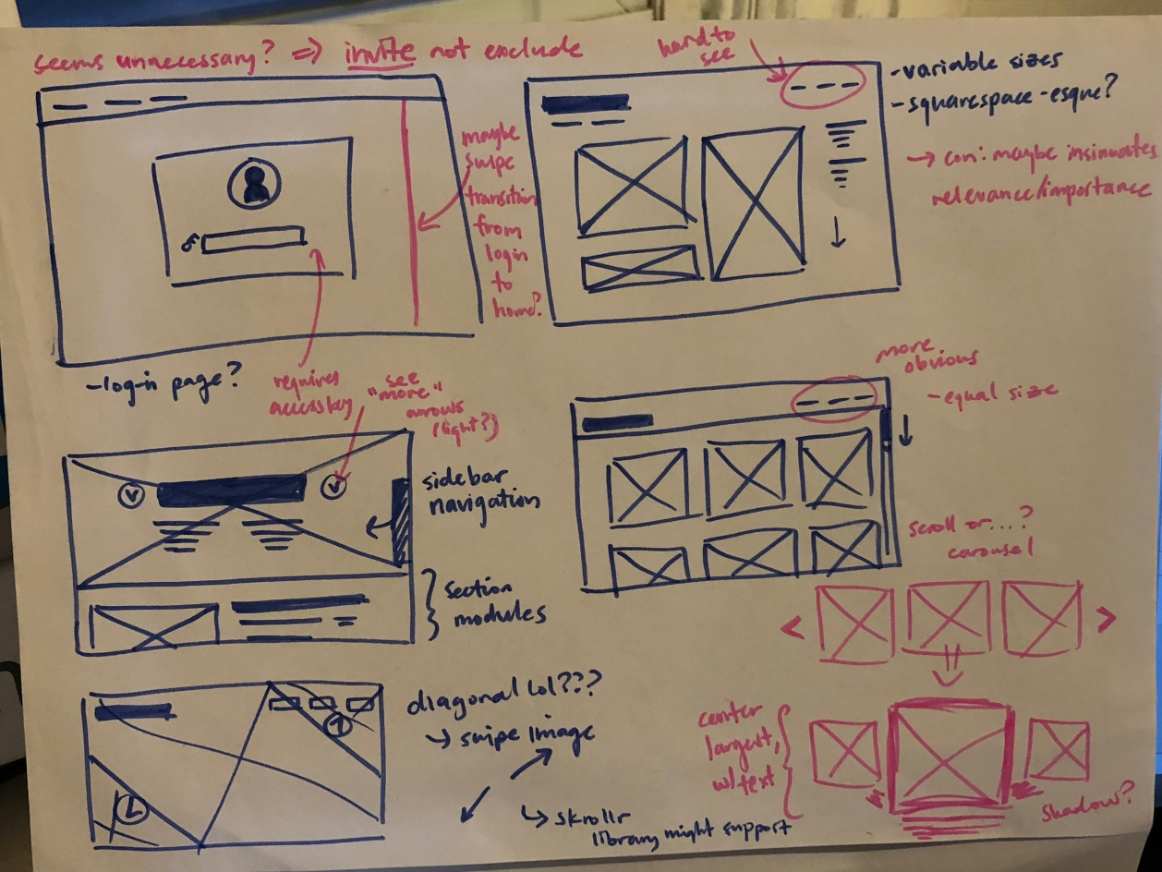

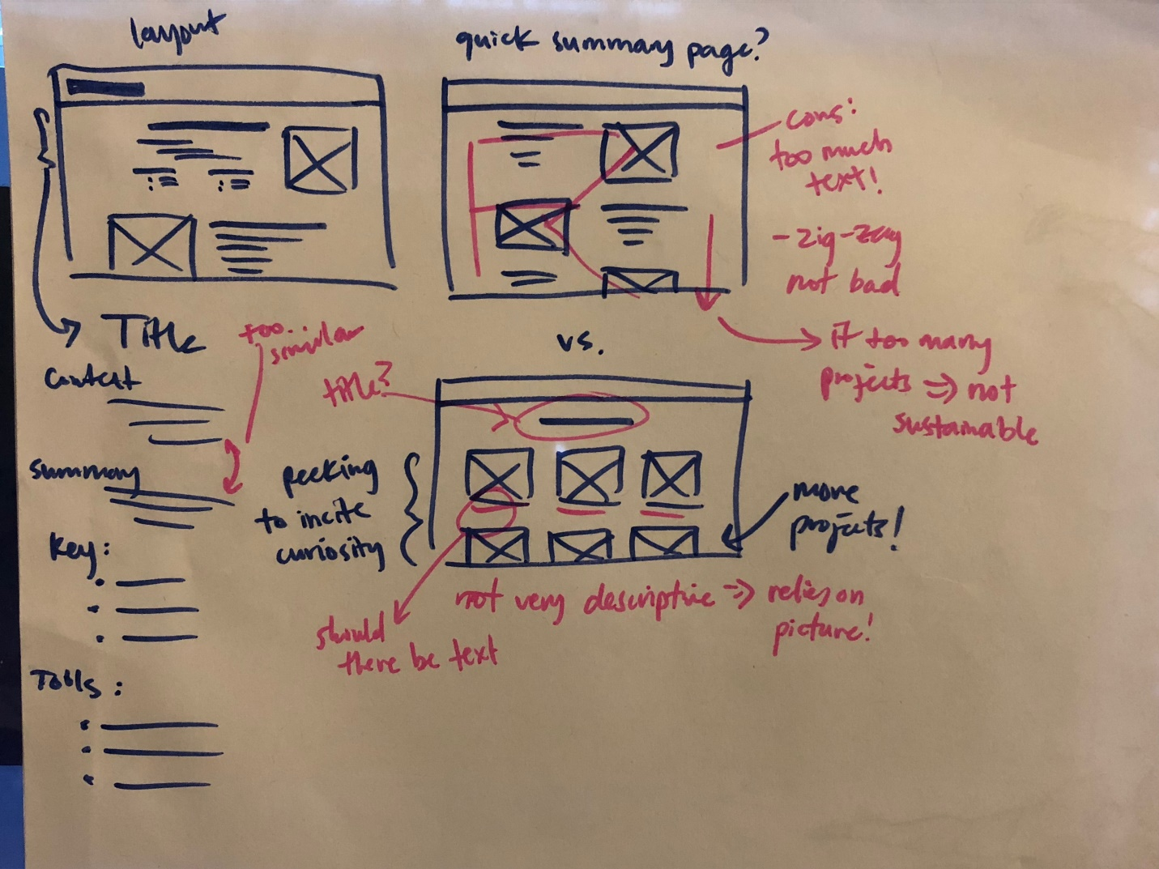

Part 5)

The biggest challenge was piecing everything I wanted to implement into one cohesive website. It was one kind of challenge to incorporate multiple functionalities and libraries, but also because it forced me to evaluate what things were even necessary. Another challenge was writing up what should go into the portfolio because I don’t have many projects or experience but I hope that is solved for now with the headings in the beginning of each project page and animated indicators of works in progress. There were some other things along the road outside of web development itself that made this project a bit difficult as well but it was a good learning experience and it taught me a lot about how to be resourceful and experimental.

\*Note: One such challenge I faced that was not resolved was a problem publishing the website on Github pages. I tried to push the files into multiple folders like Homework 8 stated but when I did so, it was unable to find the code. The second time I did so, it gave me an error message about loading my index.html file. Since we are doing critique and need to show our website, I resigned to just turn everything in and I hope that I am not too many points for this.